**ECO 32500 : Final Report**

**Fall 2023**

**Professor John Droescher**

**Report By : Mohammed Fahad & Adam Sabri**

**1. Introduction: Reframing the Question**

As the Regional Director, our primary objective is to significantly enhance this year's performance by leveraging the valuable data residing in our SQL server database. Our approach involves thorough data analysis of historical performance data, internal processes, and customer data, which are all contained within this database. Through this analysis, we aim to pinpoint opportunities for improvement and drive data-informed decision-making.

**2. Data Collection Methodology**

**Data Source**: SQL Server Database

Our single data source for this analysis is the SQL server database, which includes four key datasets:

**Historical Sales Data(Order Data):** This dataset includes past metrics such as sales and order data.

**Product Data:** This dataset contains information about our product catalog.

**Customer Data:** This dataset encompasses details about our customers, including segmentation.

**Shipping Data:** This dataset provides insights into shipping processes.

**3. Organizing Information**

Our approach to organizing and preparing this data for analysis is as follows:

**Data Cleaning and Preparation:**

We have dedicated significant effort to cleaning and preparing the data from the SQL server database. This process involves removing duplicates, errors, and inconsistencies, ensuring the accuracy and reliability of our dataset.

**4. Data Analysis for Insights**

Our data analysis process focuses on extracting actionable insights from the SQL server database:

**Historical Data Analysis:**

Through in-depth analysis of historical performance data, we have identified trends, patterns, strengths, and weaknesses that have influenced our past performance.

**Product Data Analysis:**

We've assessed product performance, identifying top-performing and poorly performing products, and correlated this with pricing data.

**Customer Data Analysi**s:

We've segmented our customers into Consumer, Corporate, and Home Office groups and analyzed their behavior and purchasing patterns over time.

**Shipping Data Analysis:**

The analysis of shipping data has revealed insights into shipping delays and their impact on sales.

**Analytical Tools:**

Python scripts and SQL queries have been essential tools in conducting comprehensive data analysis, providing us with a deeper understanding of our business dynamics.

**5. Narrative Development from Insights**

Our analysis has culminated in a compelling narrative:

**Performance Story:**

The narrative encapsulates our performance and highlights key findings, potential strategies, and actionable insights that provide a clear roadmap for performance improvement.

**6. Visualizations and Report Creation**

Our insights have been transformed into visualizations using business intelligence tools such as Tableau and PowerBI:

**Visualizations:**

These visualizations, including charts and graphs, present the data and findings in a visually comprehensible format, aiding in understanding complex information.

**Comprehensive Report:**

We have assembled these visualizations into a comprehensive report and presentation deck, which provide a holistic view of our analysis, featuring key insights and actionable recommendations. These documents are designed to facilitate clarity and data-driven decision-making.

**7. Specific Findings from Data Analysis**

Our analysis has unearthed specific and actionable findings:

**Customer Segmentation:**

We've identified three distinct customer segments – Consumer, Corporate, and Home Office – within the customer data. Visualizations track sales trends within each segment over time.

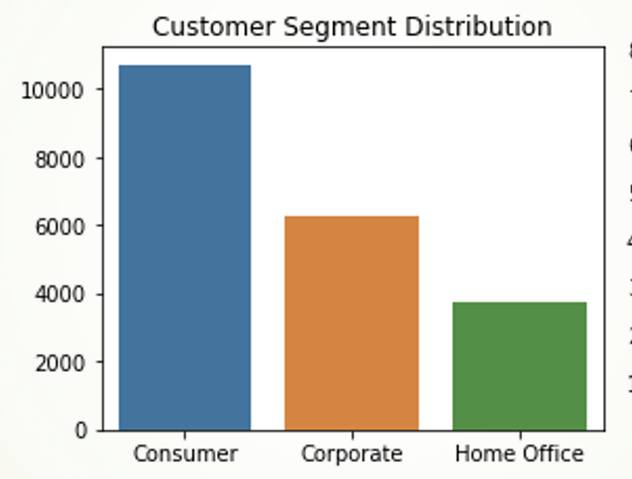

**Sales Trend Analysis:**

Our analysis has pinpointed a concerning decline in sales starting around the end of 2017

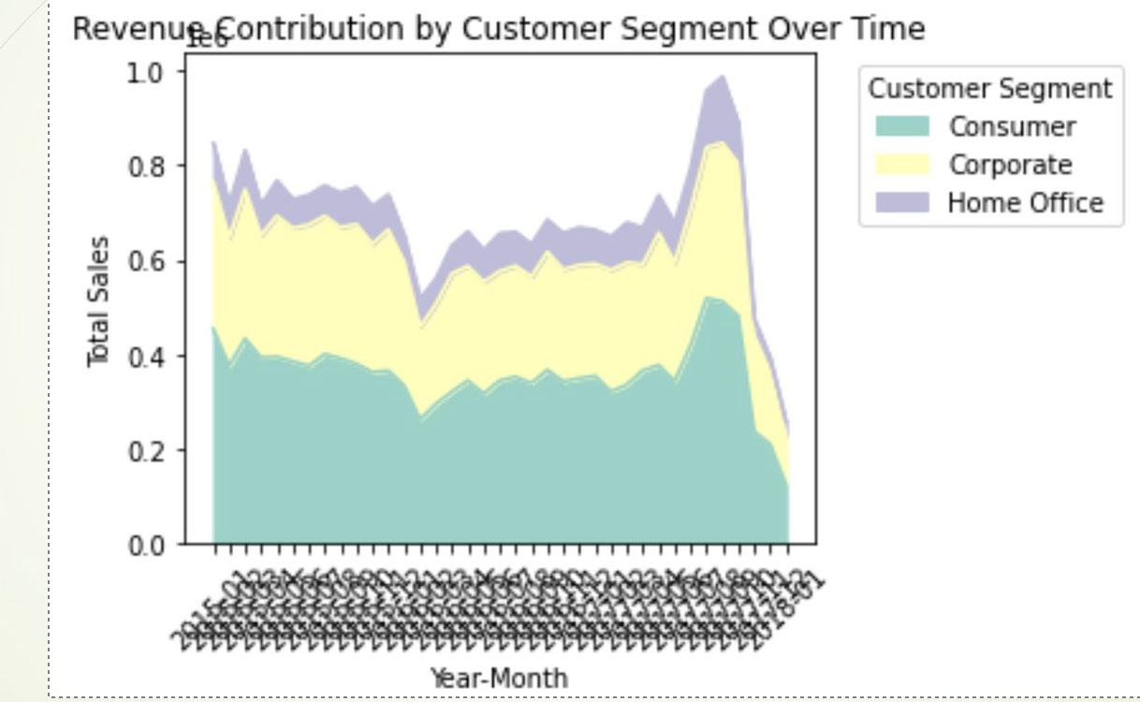

**Shipping Data Insights:**

Shipping data analysis has revealed insights into shipping delays, their causes, and their impact on sales performance.

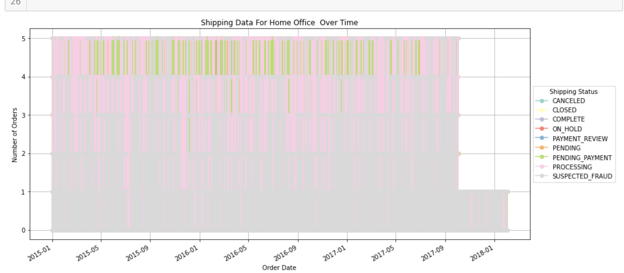

**Product Performance Analysis:**

We've assessed the performance of products, identifying trends related to price changes and their impact on sales.

Our top performing products are products where we decreased the prices over time whereas our worst performing products are products where we hiked price over time and lost sales gradually

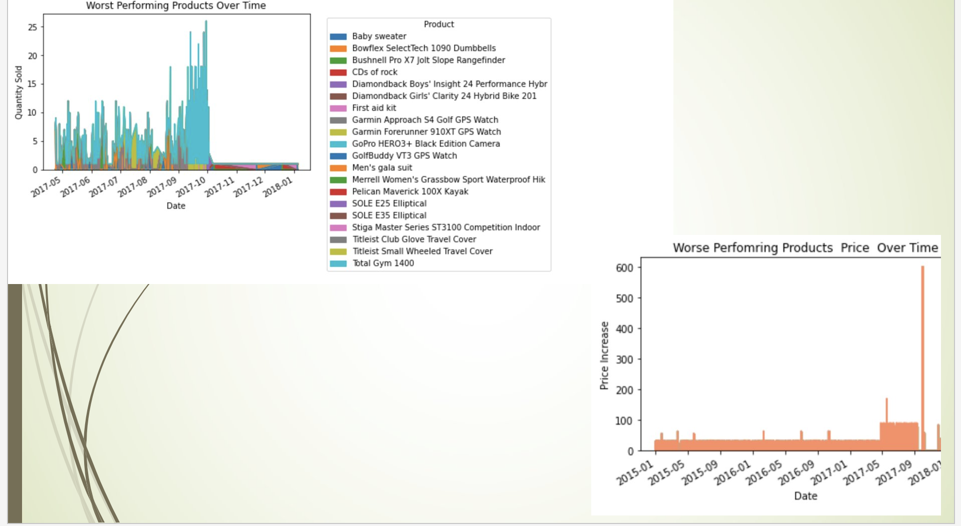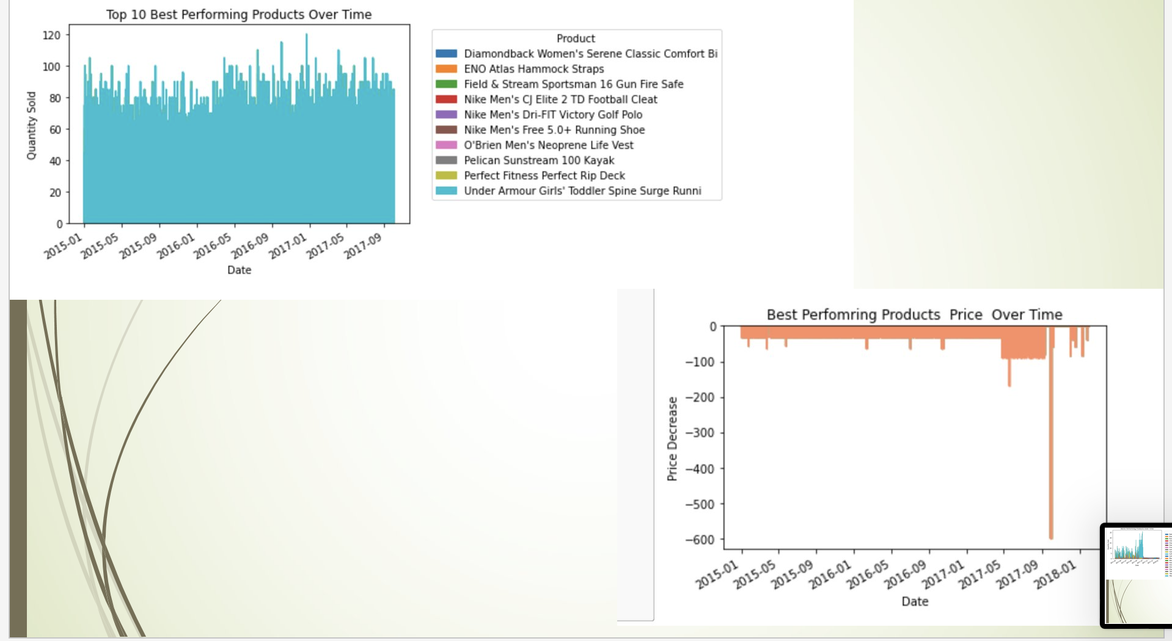

**Under Utilized Peak Sales Seasons :**

We have identified trends in our peak sales season, our overall sales tends to follow a seasonality, but based on our sales data, we do not offer any structured discounts to our top customers during this time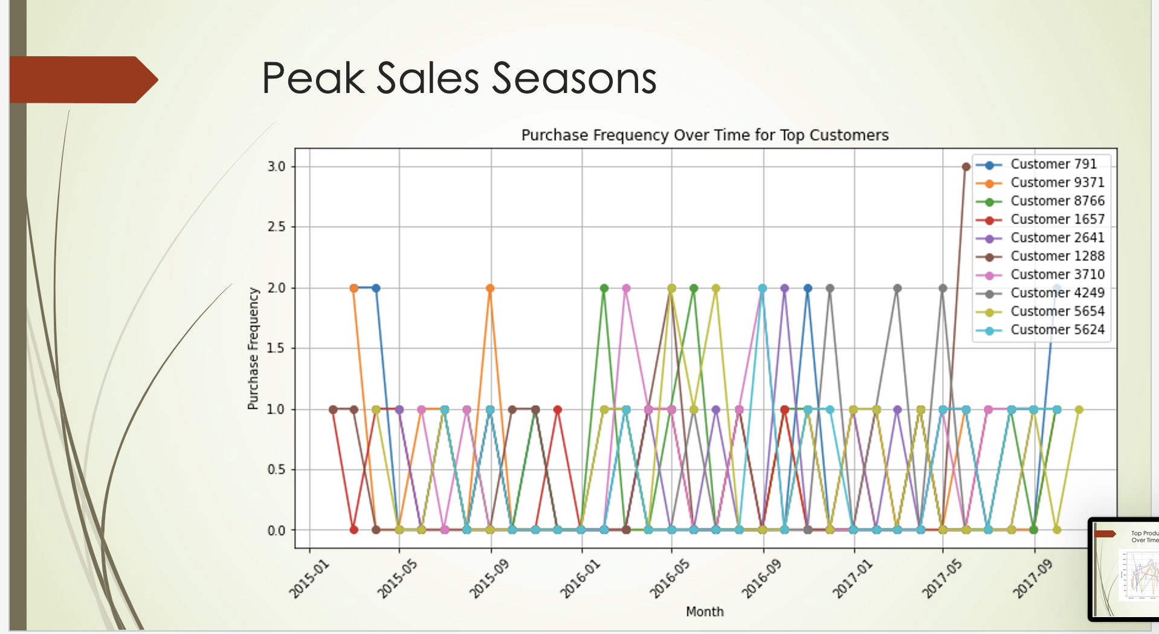

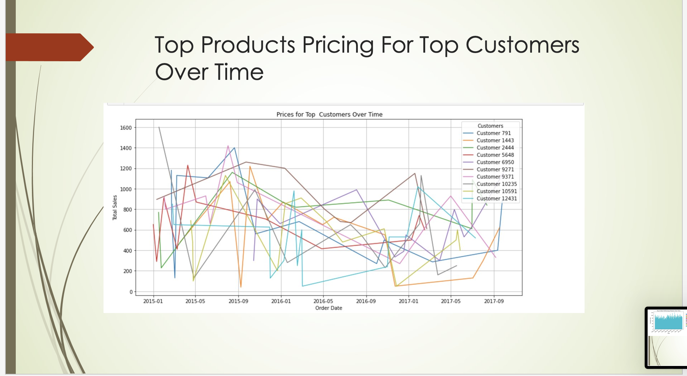

**8. Recommendations**

Our data-driven analysis has unveiled critical insights, and we recommend the following strategies to improve performance based on these findings:

**Pricing Strategy Optimization**

T**op Performing Products**: Given that top-performing products are those with price reductions over time, we recommend a dynamic pricing strategy for other products. Consider regular price assessments and adjustments based on demand and competition.

**Poorly Performing Products:** For products with gradually declining sales due to price hikes, it's essential to reassess their pricing strategy. Consider returning these products to more competitive price points to regain lost sales and market share.

**Customer Segmentation-Based Approach**

**Structured Discounts**: Implement structured discounts during peak sales seasons to incentivize purchases and capitalize on seasonal trends. Offer discounts to top customers during these periods to strengthen customer loyalty and boost sales.

Shipping Process Improvement:

**Address Shipping Delays: I**nvestigate the root causes of shipping delays and take proactive steps to streamline shipping processes. This will enhance customer satisfaction and contribute to improved sales performance, particularly in the Home Office segment.

Data-Driven Decision-Making Culture:

**Consumer, Corporate, and Home Office Segments:** Leverage customer segmentation insights to tailor marketing and product strategies for each segment. Create targeted promotions, product bundles, and campaigns to address the unique preferences and behaviors of these customer groups.

Peak Sales Season Discount Strategy:

**Continuous Data Analysis:** Foster a culture of continuous data analysis and utilization within the organization. Encourage teams to use insights derived from data to inform their decision-making processes.

By implementing these recommendations, we can leverage our data-driven insights to make informed decisions and drive significant improvements in our performance. These strategies aim to address the specific issues identified in our analysis and position us for growth and success in the coming year.